Table S1. Approximate cross-validation information criterion using Pareto (PSIS-LOO-IC) associated with each of the Bayesian multinomial logistic models fitted to explain the relationship between taxonomic groups of submerged aquatic vegetation (v), and depth (d), slope (s), and aspect (a). We considered both linear and nonlinear relationships (using splines, s) between explanatory and response variables; however, for aspect (a), given its circular nature, only cyclic splines (sc) were considered. ΔPSIS-LOO-IC represents the difference between the PSIS-LOO-IC of a given model and the value corresponding to the best-supported model (i.e., the one with the lowest value); models are ranked according to this difference.
Structure of the model | PSIS-LOO-IC | DPSIS-LOO-IC
v = s(d) + s(s) + s_{c}(a) | 21752.7 | 0
v = s(d) + s + s_{c}(a) | 21924.4 | 171.7
v = d + s(s) + s_{c}(a) | 22144.8 | 392.1
v = d + s + s_{c}(a) | 22255.4 | 502.7
v = s(d) + s(s) | 22455.8 | 703.1
v = s(d) + s_{c}(a) | 22506.3 | 753.6
v = s(d) + s | 22811.3 | 1058.6
v = d + s(s) | 22816.4 | 1063.7
v = d + s_{c}(a) | 23084.6 | 1331.9
v = d + s | 23114.5 | 1361.8
v = s(d) | 23643.7 | 1891
v = d | 24325.3 | 2572.6
v = s(s) + s_{c}(a) | 26892.3 | 5139.6
v = s(s) | 27550.1 | 5797.4
v = s + s_{c}(a) | 28041.8 | 6289.1
v = s | 28733.9 | 6981.2
v = s_{c}(a) | 29615.0 | 7862.3
v = 1 (Null) | 30553.1 | 8800.4

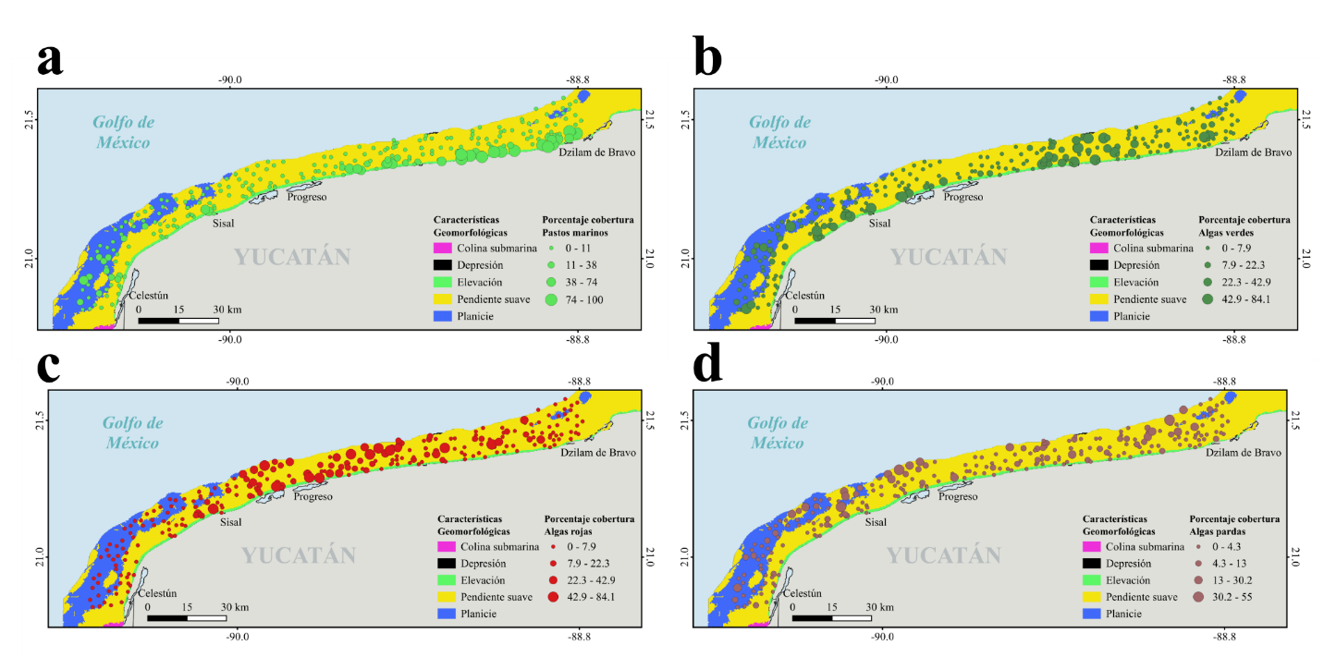
Figure S1. Percent cover, by sampling site, of seagrasses (a), green algae (b), red algae (c), and brown algae (d), at field verification sites mapped onto the geomorphological features of the shallow coastal zone of Yucatán, Mexico.

