Figure S1. Mean ± SD of a) sea surface temperature, b) Diffuse Attenuation Coefficient, c) Chlorophyll a concentration, and d) Particulate Organic Carbon. Asterisks denote level of significance (***, p < 0.001) 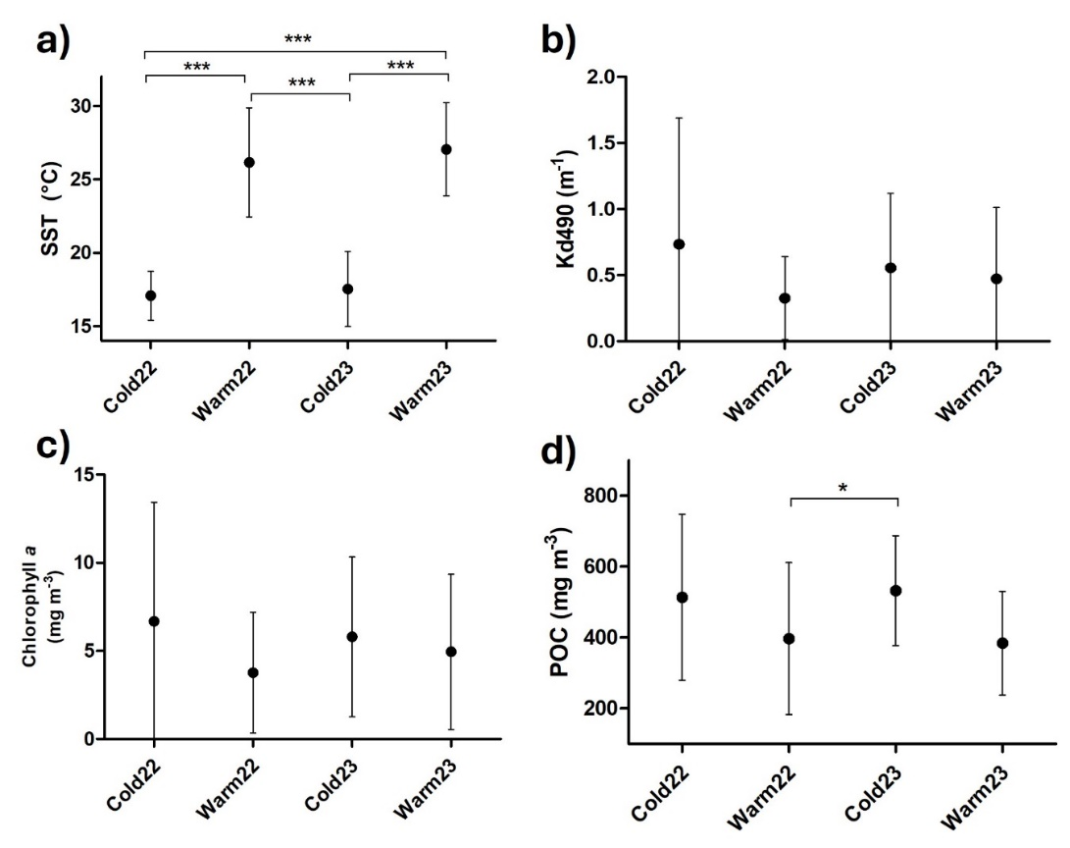

Table S1. Environmental variables Dunn's test comparisons
Environmental variable | Comparison | Z | p. unadj | p. adj
SST
 | Warm22- Warm23 | -0.45763 | 6.47E-01 | 1.00E+00
 | Warm22 - Cold22 | 5.5587193 | 2.72E-08 | 1.63E-07
 | Warm23 - Cold22 | 5.8923052 | 3.81E-09 | 2.29E-08
 | Warm22 - Cold23 | 5.4690357 | 4.52E-08 | 2.71E-07
 | Warm23 - Cold23 | 5.8069228 | 6.36E-09 | 3.82E-08
 | Cold22 - Cold23 | -0.1502663 | 8.81E-01 | 1.00E+00
POC
 | Warm22- Warm23 | -0.1479261 | 0.88240112 | 1
 | Warm22 - Cold22 | -2.0451905 | 0.04083608 | 0.2450165
 | Warm23 - Cold22 | -1.8989173 | 0.05757536 | 0.34545213
 | Warm22 - Cold23 | -2.7436098 | 0.00607677 | 0.03646063
 | Warm23 - Cold23 | -2.5956838 | 0.00944029 | 0.05664175
 | Cold22 - Cold23 | -0.6677635 | 0.50428455 | 1

Table S2. Physiological markers Dunn's test comparisons
Marker | Comparison | Z | p. unadj | p. adj
Endosymbiont density
 | Warm22- Warm23 | -0.6343023 | 5.26E-01 | 1.00E+00
 | Warm22 - Cold22 | -5.2751705 | 1.33E-07 | 7.96E-07
 | Warm23 - Cold22 | -4.7744422 | 1.80E-06 | 1.08E-05
 | Warm22 - Cold23 | -5.6931324 | 1.25E-08 | 7.48E-08
 | Warm23 - Cold23 | -5.1007816 | 3.38E-07 | 2.03E-06
 | Cold22 - Cold23 | 0.5541484 | 5.79E-01 | 1.00E+00
Chlorophyll a
 | Warm22- Warm23 | -3.992645 | 6.53E-05 | 1.96E-04
 | Warm22 - Cold23 | 0.368456 | 7.13E-01 | 1.00E+00
 | Warm23 - Cold23 | 4.616592 | 3.90E-06 | 1.17E-05
Total lipid content
 | Calida22 - Calida23 | -2.9244137 | 0.003451057 | 0.02070634
 | Calida22 - Fria22 | 1.4159478 | 0.156790802 | 0.94074481
 | Calida23 - Fria22 | 3.8375611 | 0.000124262 | 0.00074557
 | Calida22 - Fria23 | -0.3031666 | 0.761762895 | 1
 | Calida23 - Fria23 | 2.6930754 | 0.007079625 | 0.04247775
 | Fria22 - Fria23 | -1.6892301 | 0.091175343 | 0.54705206

