Supplementary material
Figure captions
Figure S1. Satellite images of Guanaja Island showing the areas (labeled in red) of the mangroves that were 97% affected by Hurricane Mitch in October 1998. [a] Before Hurricane Mitch 1998, [b] after Hurricane Mitch 1999.
Figure S2. Satellite images showing changes in mangrove coverage due to shrimp farms between: [a] 1985 (Landsat 5) and [b] 2023 (Landsat 9) on the Pacific coast, Gulf of Fonseca, Honduras.
Figure S3. Changes in the landscape of Roatán, Bay Islands, Honduras due to development from human settlements and tourism (1985-2023). [a] Landsat 5 satellite image of Roatán in 1985, [b] Current satellite image of Roatán. The areas of Coxen Hole and Mohagany Bay contained mangroves that were replaced by urbanization and development.
Figure S4. Degradation of mangroves due to deforestation and pollution on the Pacific Coast of Honduras. [a and b] Mangroves deforested for firewood and housing construction, [c and d] mangrove pollution due to solid waste and business infrastructure built on mangroves.
Figure S5. Pollution and urbanization of mangroves in Útila, Bay Islands, Honduras. Some neighborhoods are observed to be built entirely on the mangroves [a-e]. [f-h] accumulation of garbage in the mangroves of Western Path and Turtle Harbour Wildlife Refuge.
Figure S6. Presence of mangrove coverage in Cayo Mayor, Cayos Cochinos on the Atlantic coast of Honduras.
Figure S7. Presence of mangrove coverage in the Mosquitia region, Department of Gracias a Dios, Atlantic coast of Honduras: a) and b) Mangrove areas in relatively preserved conditions with evidence of human influence; c) and d) Mangroves affected by solid waste pollution.

Figure S1.

Figure S2.

Figure S3.
a)
b)

Figure S4.

Figure S5.

Figure S6.
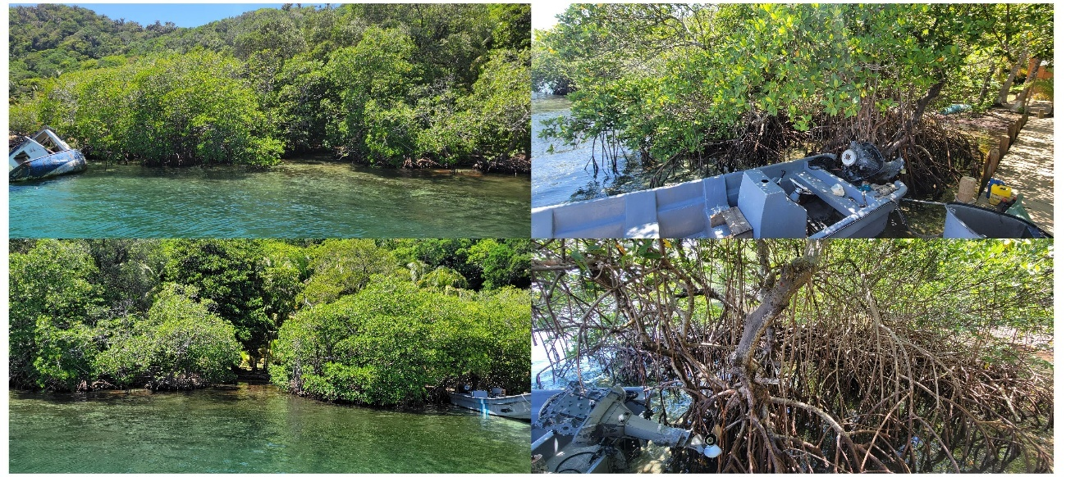

Figure S7.
