Table S1. Description of chromatophore patterns and siphon size as diagnostic characteristics for paralarval identification.
Criterion | Description
Siphon size
Small | Covers <25% of the head
Medium | Covers 50% of the head and extends to the base of the eyes
Large | Covers >50% uo to 100% of the head
Chromatophore pattern  MDCP  MVCP  DHCP  VHCP  SCP  DGCP* | Dorsal Mantle Chromatophore Pattern  Ventral Mantle Chromatophore Pattern  Dorsal Head Chromatophore Pattern  Ventral Head Chromatophore Pattern  Siphon Chromatophore Pattern  Digestive Gland Chromatophore Pattern
*Arranged in rows from the anterior to the posterior region following the scheme proposed by Sweeney et al. (1992) (Applicable only to octopods).

Table S2. Environmental variables in the neritic environment of the Northern Colombian Pacific from January to November 2022. (N: North; C: Center; S: South; SST: Sea Surface Temperature; DO: Dissolved Oxygen).
Month | Sector | Variables (Mean ± Standar deviation)
 |  | SST  (°C) | Salinity  (PSU) | DO  (mg·L⁻¹) | Chlorophyll-a  (µg·L⁻¹) | Biomass  (mg·m⁻³)
Jan | N | 27.78 ± 0.36 | 29.06 ± 0.30 | 4.01 ± 0.19 | 0.35 ± 0.17 | 5.48 ± 3.23
Jan | C | 28.00 ± 0.35 | 28.66 ± 0.44 | 4.32 ± 0.21 | 0.38 ± 0.21 | 2.16 ± 1.22
Jan | S | 27.22 ± 0.45 | 25.11 ± 6.04 | 4.36 ± 0.24 | 1.37 ± 0.96 | 3.11 ± 3.38
Mar | N | 28.63 ± 0.33 | 31.05 ± 0.28 | 4.45 ± 0.21 | 0.54 ± 0.14 | 42.79 ± 22.82
Mar | C | 27.67 ± 0.54 | 30.64 ± 0.78 | 4.70 ± 0.29 | 0.94 ± 0.33 | 22.60 ± 16.38
Mar | S | 27.30 ± 0.36 | 25.03 ± 9.42 | 4.14 ± 0.42 | 1.91 ± 0.79 | 14.37 ± 7.47
May | N | 28.07 ± 0.14 | 26.79 ± 0.37 | 4.10 ± 0.15 | 0.32 ± 0.14 | 14.87 ± 20.04
May | C | 28.33 ± 0.31 | 26.10 ± 0.59 | 4.74 ± 0.22 | 0.40 ± 0.11 | 7.52 ± 9.01
May | S | 27.97 ± 0.50 | 21.00 ± 6.28 | 4.39 ± 0.35 | 1.27 ± 0.75 | 9.63 ± 8.31
Jul | N | 27.75 ± 0.31 | 25.58 ± 0.71 | 4.64 ± 0.16 | 0.24 ± 0.08 | 4.07 ± 2.85
Jul | C | 27.87 ± 0.22 | 24.22 ± 0.40 | 4.62 ± 0.10 | 0.27 ± 0.12 | 4.21 ± 2.22
Jul | S | 27.94 ± 0.61 | 19.95 ± 5.85 | 4.78 ± 0.40 | 1.27 ± 0.88 | 3.20 ± 2.84
Sep | N | 28.16 ± 0.34 | 24.53 ± 0.40 | 4.16 ± 0.64 | 0.27 ± 0.11 | 4.93 ± 3.59
Sep | C | 28.23 ± 0.32 | 24.10 ± 0.46 | 3.79 ± 0.50 | 0.41 ± 0.14 | 6.25 ± 3.11
Sep | S | 26.75 ± 0.37 | 17.27 ± 3.10 | 2.82 ± 0.62 | 1.77 ± 0.77 | 4.09 ± 3.06
Nov | N | 27.23 ± 0.46 | 23.55 ± 0.44 | 4.53 ± 0.17 | 0.27 ± 0.05 | 10.37 ± 8.59
Nov | C | 27.11 ± 0.26 | 20.36 ± 1.22 | 4.64 ± 0.09 | 0.61 ± 0.30 | 6.91 ± 10.80
Nov | S | 26.33 ± 0.22 | 17.98 ± 1.29 | 4.39 ± 0.23 | 2.90 ± 1.05 | 7.60 ± 7.32

Table S3. Description of morphological characteristics of cephalopod paralarvae taxonomic groups identified in the neritic environment of the Northern Colombian Pacific between January and November 2022. (n: Number of individuals; DML: Dorsal Mantle Length; DS: Dorsal Surface; VS: Ventral Surface; AI: Arm I; AII: Arm II; AIII: Arm III; AIV: Arm IV; TC: Tentacular Club; DG: Digestive Gland).
Group | n | DML (mm) | Mantle | Head | Arms | Tentacles | Siphon
Loliginidae
Morphotype I | 18 | 1.2  -  2 | DS: One chromatophore at the base of each fin.  VS: 21 to 24 chromatophores arranged in six rows, anterior region more pigmented than posterior región  (VMCP: 5+5+5+4+2). | DS: No chromatophores observed. VS: Eight chromatophores arranged in three rows. (VHCP: 2+2+4). | AI: Formed at 1.71 mm DML, without visible suckers or chromatophores. AII: One large sucker on the distal part, without chromatophores. AIII: Two to four suckers arranged in two rows, without chromatophores. AIV: One large sucker on the distal part, with one to two chromatophores on the aboral surface. Formula: AIII>AII≈AIV>AI (Fig. 3c). | Two to three chromatophores along the aboral surface.  TC: Undifferentiated (same width as the peduncle). From 1.2 to 1.5 mm DML with six biseriate suckers. From 1.6 to 2 mm DML with 10 biseriate suckers, the distal ones are relatively smaller than the proximal ones (Fig. 3c-d). | Small, no visible chromatophores, straight cartilaginous brooch.
Morphotype II | 8 | 1.78  -  2.9 | DS: Two relatively large chromatophores in the middle region and one at the base of each fin. VS: With a range of 20 to 22 chromatophores arranged in five rows, the anterior region is more pigmented than the posterior región (VMCP: 5+5+5+3+2). | DS: Two small chromatophores in the middle of the eyes.  VS: Eight chromatophores in three rows. (VHCP: 2+2+4). | AI: Formed at 2.35 mm DML, without visible suckers or chromatophores. AII: One large sucker on the distal part, without chromatophores. AIII: Six to eight biseriate suckers, the distal ones relatively smaller, without chromatophores. AIV: With one large sucker on the distal part, two chromatophores on the aboral surface. Formula: AIII>AII>AIV>AI (Fig. 3e). | Four chromatophores on the aboral surface. TC: Differentiated (wider than the peduncle), peduncle without suckers.  At 1.78 to 1.9 mm DLM: TC slightly thickened with proximal biseriate suckers. Middle and distal region with suckers arranged in three to four rows (Fig. 3e-f). From 2.35 DML onwards: club markedly differentiated, proximal region with six to eight biseriate suckers; middle and distal regions with 12 to 16 suckers arranged in three to four rows. | Small, no visible chromatophores, straight cartilaginous brooch.
Morphotype III | 4 | 1.8  -  2.8 | DS: Two relatively large chromatophores in the middle region and one at the base of each fin. VS: With a range of 17 to 21 chromatophores arranged in five rows, the anterior region is more pigmented than the posterior region. (VMCP: 5+5+5+3+2). | DS: Two small chromatophores in the middle of the eyes and two in the posterior region. VS: Eight chromatophores arranged in three rows (VHCP: 2+2+4). | AI: Formed at 2.7 mm DML, without visible suckers or chromatophores. AII: One large sucker on the distal part, without chromatophores. AIII: Eight suckers arranged in two rows, without chromatophores. AIV: One large sucker on the distal part, with one to two chromatophores on the aboral surface.  Formula: AIII>AII>AIV>AI (Fig. 3g). | No chromatophores.  TC: Differentiated, peduncle without suckers. In all sizes, the club suckers are of equal size and arranged in four rows. (Fig. 3g-h). | Small, no visible chromatophores, straight cartilaginous brooch.
Ancistrochei-ridae (Ancistrochei-rus cf. lesueurii) | 6 | 0.8  -  1.1 | Bell-shaped, with a pair of small terminal fins in the posterior region, without visible photophores or chromatophores. | Proximal region covered with gelatinous tissue, slightly pedunculated and prominent eyes, no visible photophores or chromatophores. | Slightly pedunculated, covered with gelatinous tissue.  At 0.8 mm DML:  AI, AII, and AIV: One large pedunculated sucker on the distal part.  AIII: Not formed.  Formula:  AII>AIV≈AI  At 1.1 mm DML:  AI: Two pedunculated suckers arranged in a row. AII: Two pedunculated suckers arranged in a row. AIII: No suckers. AIV: One large pedunculated sucker at the distal end. Formula: AII>AI>AIII>AIV  (Fig. 4c). | Long and thin, more than ¼ of the DML. At 0.8 mm DML, they are the same size as AII. At 1.1 mm DML, they are at least twice the length of AII.  TC: Undifferentiated, with large, pedunculate suckers arranged in two rows. (Fig. 4c-d). | Small, straight cartilaginous brooch.
Ommastre-phidae (S-D Complex) | 28 | 0.8  –  1.93 | Muscular, bell-shaped, with a pair of paddle-shaped posterior fins. Photophores absent. DS: Five to ten chromatophores (DMCP: 2-5+3). VS: Two posterior chromatophores. | DS: Six chromatophores (DHCP: 1+2+3) and two additional ones, each located in the lateral region proximal to the mantle. VS: No visible chromatophores. | Between 0.6 and 1.69 mm DML:  AI: One sucker. AII: One sucker. AIII: No suckers. AIV: Not formed. Formula:  AII>AI>AIII.  At 1.9 mm DML:  AI: Six suckers in two rows. AII: Six suckers in two rows, the distal ones relatively smaller. AIII: Five large alternating suckers. AIV: Barely visible, in the form of small papillae on the base of the proboscis, without suckers. Formula: AII$≈$AI>AIII>AIV. | Proboscis: With eight suction cups of equal size at the distal end (Fig. 5c-d). The proximal region is wider than the distal region. Overall, its length represented between 75-100% of the DML.  No evidence of the beginning of tentacle separation. | Medium, cartilaginous clasp in the shape of an inverted T.
Octopodidae (Octopus cf. mimus) | 25 | 0.73  –  1.45 | Muscular and oval.  DS: Seven to ten chromatophores in the posterior region. VS: Densely pigmented with 20 to 33 chromatophores, with a consistent pattern of four to five chromatophores on the anterior margin. DG: Densely pigmented, with six to eight chromatophores. (Fig. 6d-f). | Same width as mantle. DS: 10 chromatophores (DHCP: 2+4+4). VS: Between two and four chromatophores (VHCP: 2+2).  Large, prominent eyes with iridescence around the eyeball. | Subequal, elongated distal end and pointed tip, ventral arms more pigmented than dorsal arms.  AI and AII: One to two chromatophores arranged in a longitudinal row. AIII and AIV: Three to four chromatophores arranged in the same way. All arms with three to four suckers arranged in a row (Fig. 6c-e). | Absent | Robust and medium-sized, with two chromatophores on the back and between three and four on the front (SCP: 3(4)+2).

Table S4. Results of Tukey’s multiple comparison test among sampling months. Pairs marked with * represent months with significant differences (P < 0.05; α = 0.05).
Months | Difference between means | Lower limit of the 95% confidence interval | Upper limit of the 95% confidence interval | P-value
Jul – Jan | 0.28 | -0.24 | 0.80 | 0.458
Mar – Jan | 0.78 | 0.26 | 1.30 | 0.004*
May – Jan | 0.12 | -0.40 | 0.64 | 0.959
Nov – Jan | -0.11 | -0.63 | 0.41 | 0.976
Sep – Jan | -0.10 | -0.62 | 0.42 | 0.984
Mar – Jul | 0.50 | -0.02 | 1.02 | 0.062
May – Jul | -0.16 | -0.69 | 0.36 | 0.879
Nov – Jul | -0.39 | -0.91 | 0.13 | 0.183
Sep – Jul | -0.38 | -0.90 | 0.14 | 0.200
May – Mar | -0.66 | -1.18 | -0.14 | 0.012*
Nov – Mar | -0.89 | -1.41 | -0.37 | 0.001*
Sep – Mar | -0.88 | -1.40 | -0.36 | 0.002*
Nov – May | -0.23 | -0.75 | 0.29 | 0.66
Sep – May | -0.22 | -0.74 | 0.30 | 0.695
Sep – Nov | 0.01 | -0.51 | 0.53 | 1.000

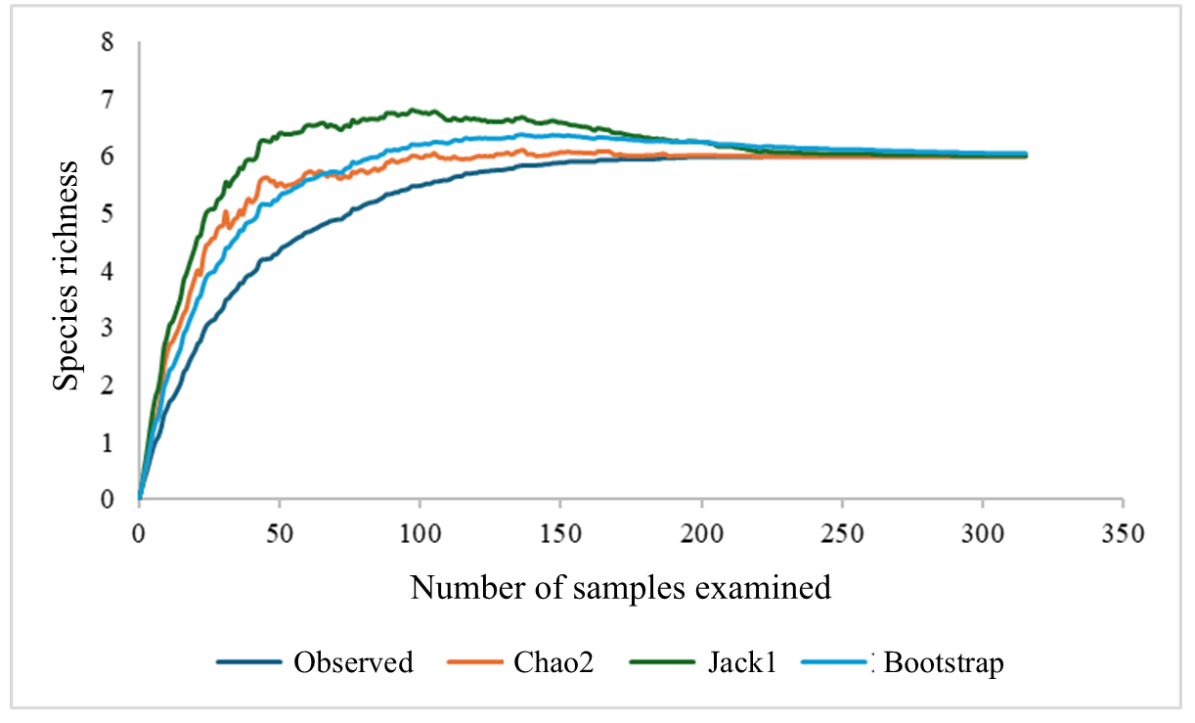

Figure S1. Species accumulation curve of cephalopod paralarvae taxonomic groups found between January and November 2022 in the neritic environment of the Northern Colombian Pacific.

